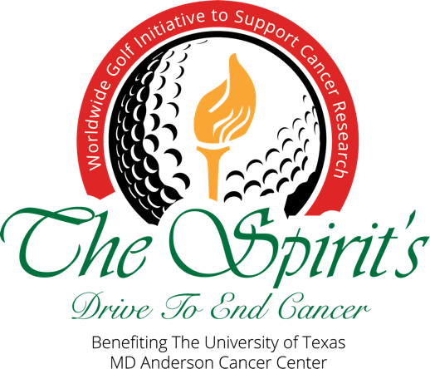  Thank you for joining our Drive to End Cancer event.  You are joining golfers across the world, with a singular goal – to put an end to cancer. A portion* of your $125 donation/entry fee will benefit The University of Texas  MD Anderson Cancer Center and its tireless effort to eradicate cancer. Many of us have been touched by this relentless disease, and together we can touch others by supporting research led by champions like MD Anderson Cancer Center.  Sincerely,  Charlie Epps, President -The Spirit Golf Association | PLAYER REGISTRATION FORM  CLUB NAME:  CLUB CITY, STATE:  Please complete this registration form to participate in this club’s Drive to End Cancer event. Thank you for helping us support cancer research.  Format: 2 Player Teams/ Best Ball  Player #1  Name:  Email:  Phone:  Address:  Honoree:  Player #2  Name:  Email:  Phone:  Address:  Honoree:  $125 Donation/Entry Fee Per Player  Make checks payable to the club. You may mail/drop-off directly to your participating golf club.  Please let us know if you’d like to make an additional donation directly to The University of Texas MD Anderson Cancer Center.

